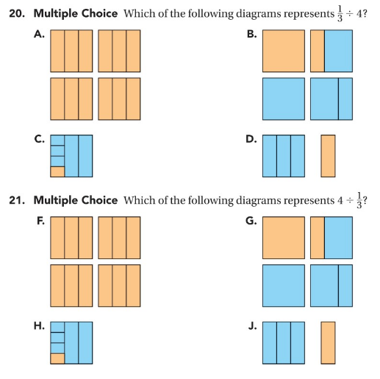
I know the answer is
because:

I know the answer is
because:

