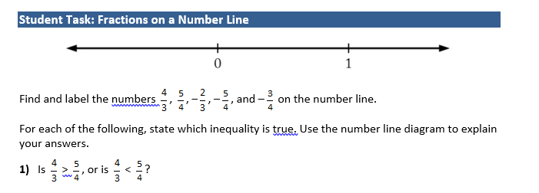
F. Fractions, inequalities, and plotting points on a number line!
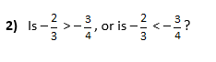
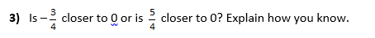
__________________________________________________________________________________________________
G. Unit Rate
Jordan is paid $60 for 4 hours of work.
- At this rate, how much would Gianna make for 9 hours of work?

- At this rate, how long would Jordan have to work to make $90?
__________________________________________________________________________________________________
H . Fraction word problems
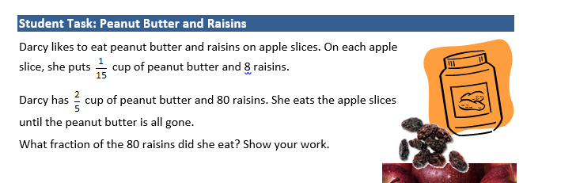

Please use a blank piece of paper to show all of your work!
A. Percents
The number of chocolate cookies that a baker makes each day is 40% of the total number of cookies she makes.
1. On Monday, the baker makes a total of 60 cookies. How many chocolate cookies does the baker make on Monday?

2. On Tuesday, the baker makes 36 chocolate cookies. What is the total number of cookies that the baker makes on Tuesday?
B.
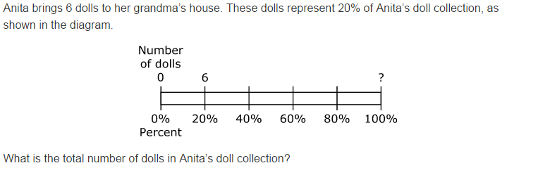
C. Greatest Common Factor & Least Common Multiple (GCF &LCM)
1. Find the GCF and LCM of 10 and 30.
2. Find the GCF and LCM of 6 and 20.

D. Define the following terms and give an example of each term.
1. Sum 2. Difference 3. Quotient 4. Product 5. GEMS (hint order of operations!)
6. Absolute Value 7. Equivalent expressions 8. Distributive Property 9. Substitution

E. Use the distributive property, combining alike terms, and order of operations to match the equivalent expressions.
A. 6(c+2) + c 1. 4n + 24
B. n+n+n+n+5+5 2. 7c + 12
C. 4(n+2 )+ 10+6 3. 2c+12
D. 2c+10+c-c+2 4. 4n + 10

