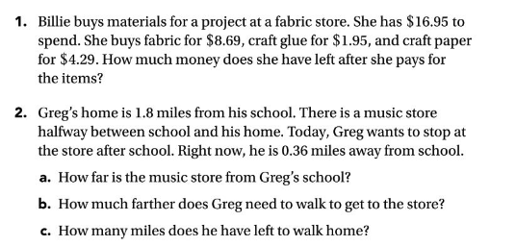
Use close reading strategies to answer the problems below. Show all of your work!

Name
Homework 1.24
Use close reading strategies to answer the problems below. Show all of your work!

