For each problem, write TWO different expressions using the distributive property. Then, find the area
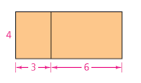 | Expression 1
 | Expression 2
 | Area
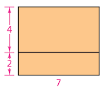 | Expression 1
 | Expression 2
 | Area
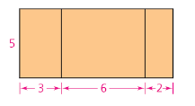 | Expression 1
 | Expression 2
 | Area
4. Find 3 different whole number lengths and widths that would make the rectangles have areas of 12 and 27. 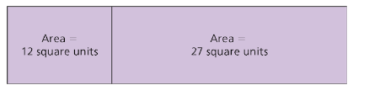 | 1.
 | 2.
 | 3.

