Name:
Homework 2.14
Directions: Plot and label each point on the coordinate plane below
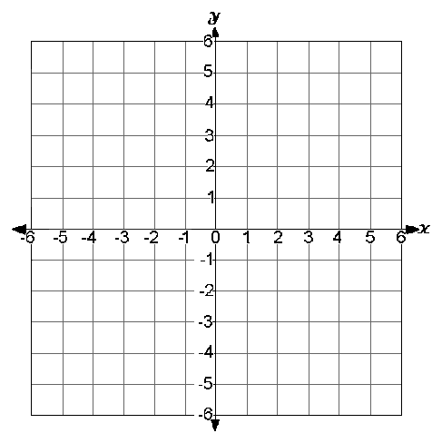
A = (0,5)
B = (4,3)
C = (3,4)
D = (2,0)
E = (-2,6)
F = (-4,-3)

